From the President:
We have some fun things coming up with the UCXC. At the Mar 6th meeting we will be presenting the High Plains Honor Flight with a check both from the club and from the Super Bowl pool with Codi and Scott ran. Our speaker that night will be Sharon Eberhardt with Life Stories which is the prevention of child abuse agency we support. Sharon will be letting us know what is going on with them. We will be presenting her with a check as we are sponsors of their annual gala fundraiser, Canto Bight Casino Night. As a sponsor we receive 10 tickets to the gala. We will have a drawing that night for those tickets. We will draw for 5 sets of 2 tickets. This event is 4/21/23 at 6pm-11pm at Aims Welcome Center. You will need to be at that meeting to be eligible to win the tickets. It’s a fun night. Our fun meeting for March will be moved to 3/18/23 to attend the Stars of Tomorrow Show at UCCC presented by the Kiwanis Club. Tickets are $15. If you plan to attend let Codi know and she’ll collect the money for your tickets at the 3/6 meeting. Once she has a head count she’ll make arrangements for the dinner/drinks for before/after the show. Don’t forget to let me know what size t-shirt you’d like and if you’d like to purchase a polo.
Carolyn

Union Colony Exchange Club
March 2023 Newsletter

What You Need To Know…
President: Carolyn Geisert
970-302-9643
President Elect: Pat Lawler
970-371-4818
Immediate Past President:
John Zack
970-381-7890
Secretary: Karen Zack
970-381-3465
Treasurer: Kim Slack
970-397-0332
Board Members:
Sue Wheeler 330-687-5445
Miki Johnson 970-370-3909
Newsletter: Terri Keeney
970-396-4267
This Photo by Unknown Author is licensed under CC BY-ND
March Birthdays:
Teri Whiteley 3/6
Karen Zack 3/25
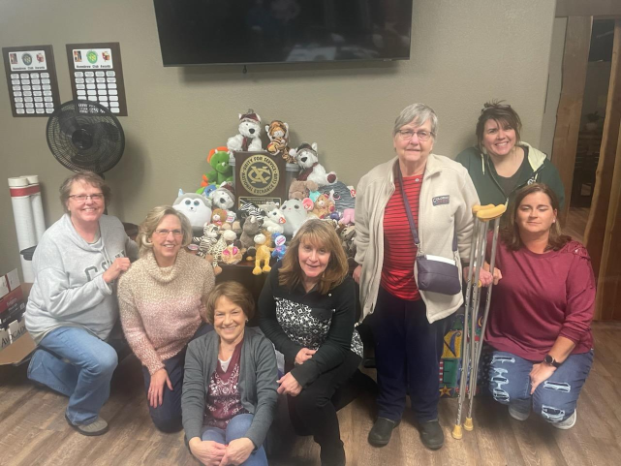
Union Colony Exchange Club members L-R Pat, Karen, Miki, Carolyn, Margaret, Lorie and Codi with the stuffed animals given to Life Stories for their Stuffed With Love toy drive. The stuffed animals will be given to children as a comfort after witnessing or being victim to a crime.
This was our Prevention of Child Abuse Project.

3/6-meeting; presentation to High Plains Honor Flight; speaker/presentation Sharon Eberhardt with Life Stories

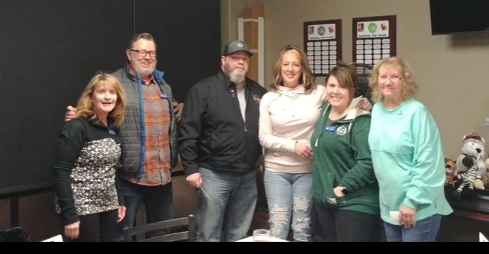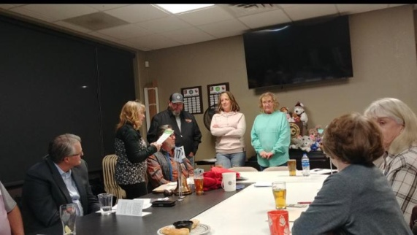
Carolyn, Brian, Rod, Teri, Lori and Cindy Carolyn, Rod, Teri and Cindy
New members Rod & Teri Whiteley and Cindy McPhee were inducted into the Union Colony Exchange Club in February. Thanks to sponsors Brian and Lorie and Carolyn for helping our club to grow! Welcome aboard (officially!) Rod, Teri and Cindy! So glad to have you with us!

Codi is coordinating our social time in March and is planning on having all who’d like to attend the Kiwanis Club of Greeley’s Stars of Tomorrow Show. It’s March 18th at the UCCC and starts at 7pm. Tickets are $15 each, general admission. Once she has a headcount she’ll also coordinate a dinner/drinks portion for the evening. Her number is 970-978-1755. Money collected at the March 6th meeting.

