From the President:

Happy June to all.
It is with happy thoughts that I look forward to the summer ahead! Life is almost returning to “normal”. As we have resumed our meetings in-person at Kenny’s everyone seems to be enjoying our time together. Although we are still missing a few, our last meeting had a full room. Stampede is going to happen, even with a lot of changes, and we have a fundraiser in our future! I hope that most of you will be able to participate, in any way you can. If you have questions, please do not hesitate to ask me or Carolyn. I also look forward to our upcoming year. As John enters as our next President, I feel very confident that we will grow and thrive as a club.
May God Bless you All,
Debbie

Union Colony Exchange Club
June 2021 Newsletter

What You Need To Know…
President: Debbie Casdorph
970-381-6137
President Elect: John Zach
970-381-7890
Immediate Past President:
& Division 6 Director
Karen Zack 970-381-3465
Secretary: Carolyn Geisert
970-302-9643
Treasurer: Kim Slack
970-397-0332
Board Members:
Sue Wheeler 330-687-5445
Miki Johnson 970-371-3909
Kork Johnson 970-301-6650
Newsletter: Terri Keeney
970-396-4267

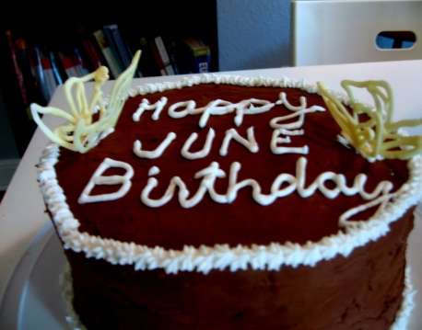
This Photo by Unknown Author is licensed under CC BY-SA-NC
Chris Ruth, 6/10

Upcoming Speakers:
6/7/21: TBD
6/21/21: TBD
This Photo by Unknown Author is licensed under CC BY-SA-NC

Calendar Recap:
6/7/21 6:30 meeting at Kenny’s
6/21/21 6:30 meeting at Kenny’s
SOCIAL TIME AT 6PM BEFORE THE MEETING STARTS AT 6:30 HAS STARTED AGAIN!

Zoom meeting Thurs. 6/3/21 at 6:30pm
Submit questions to Debbie prior to meeting.

Memorial Day at Linn Grove Cemetery with Wreaths Across America sponsored by Union Colony Exchange Club…
This Photo by Unknown Author is licensed under CC BY
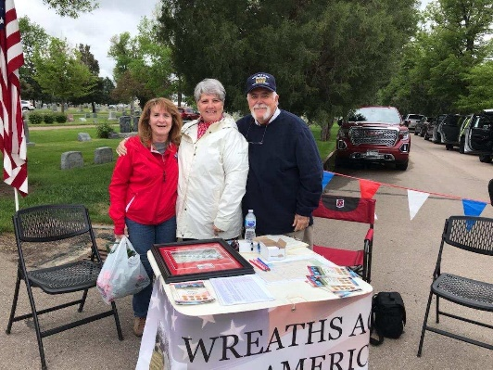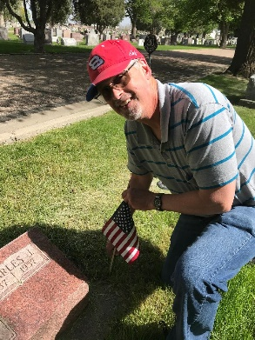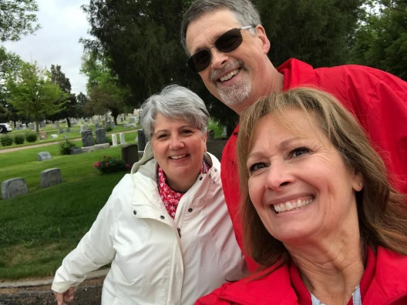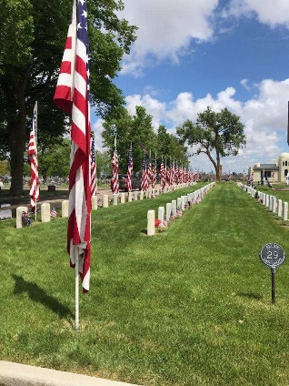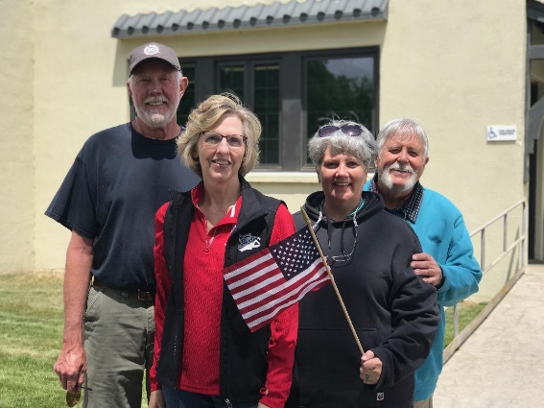
Union Colony Exchange Club members Carolyn Geisert, Brad & Terri Keeney, John & Karen Zack and Bill & Chris Ruth placing flags, manning WAA table and greeting at gate on 5/31/21

